[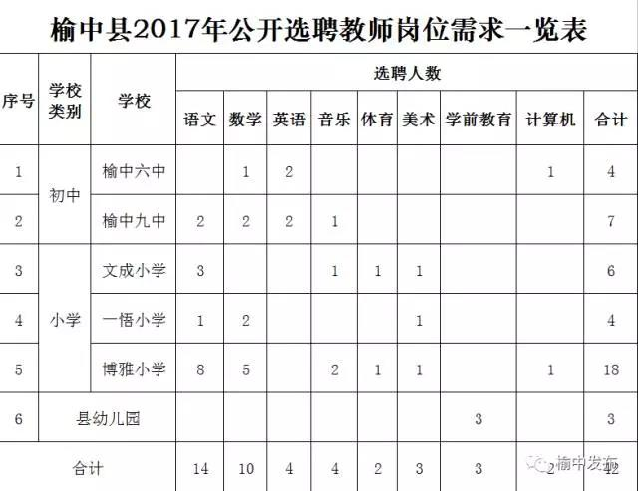](http://yzx.lanzhou.gov.cn/picture/0/1707271031154658148.jpg)