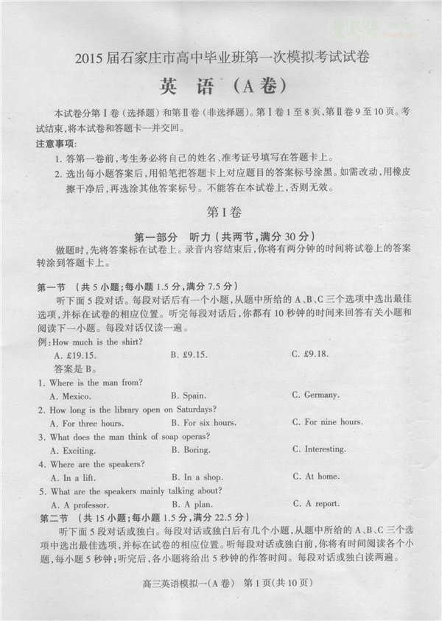

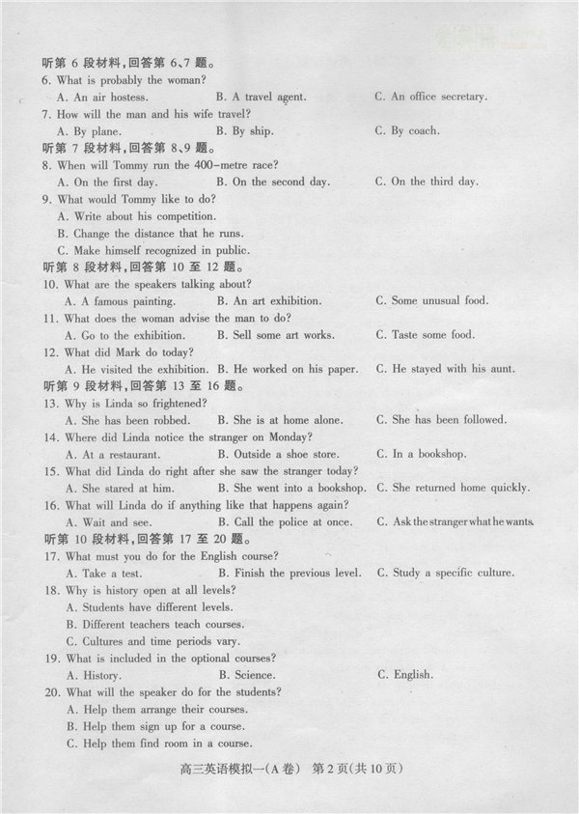

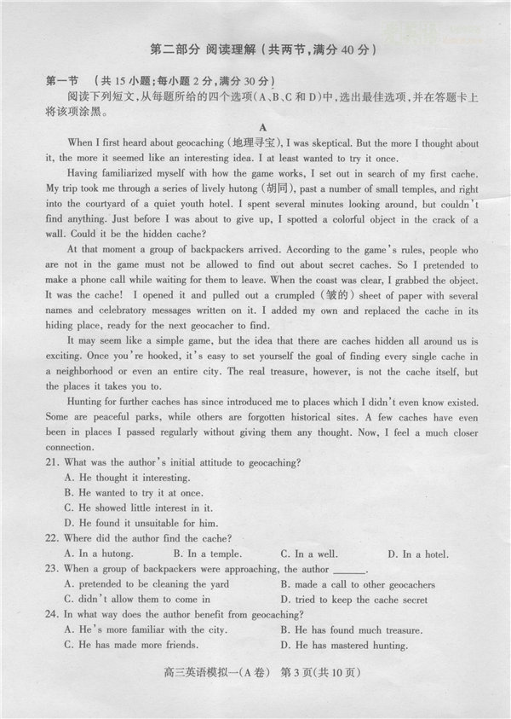

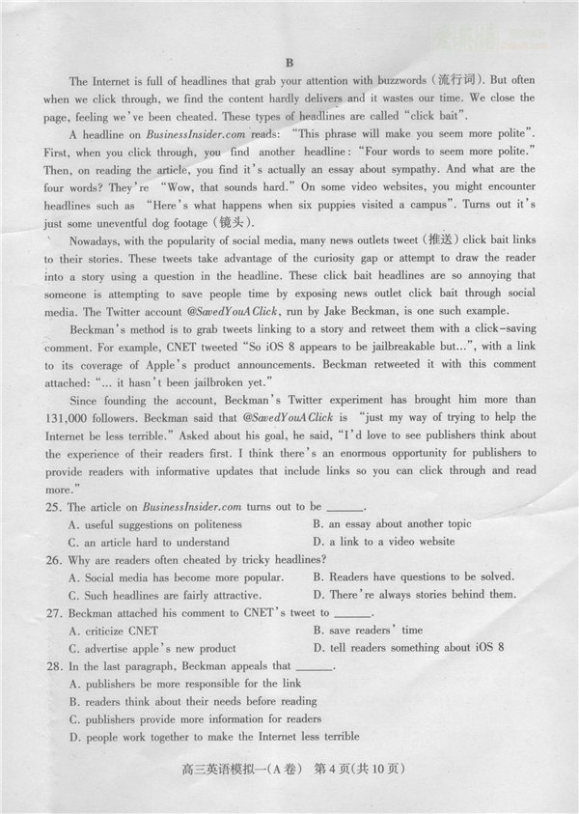

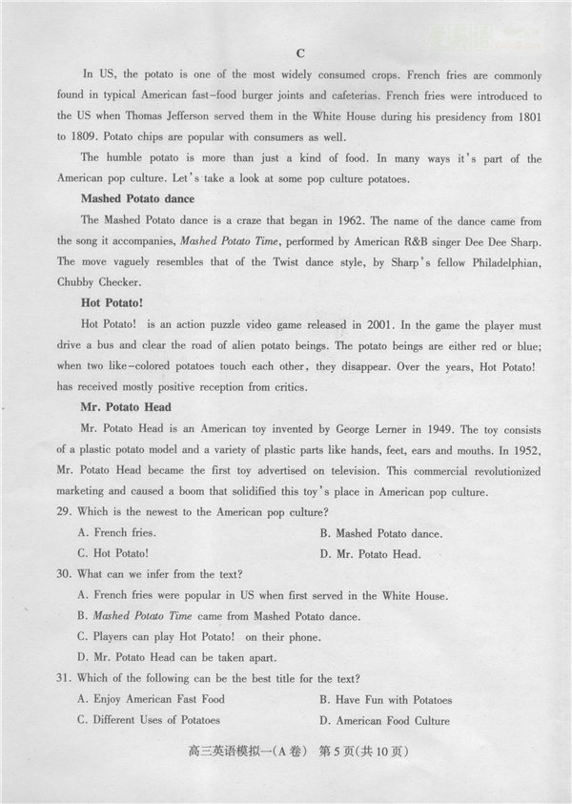

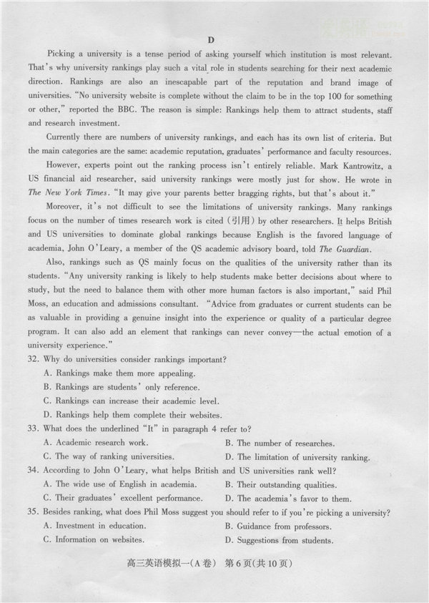

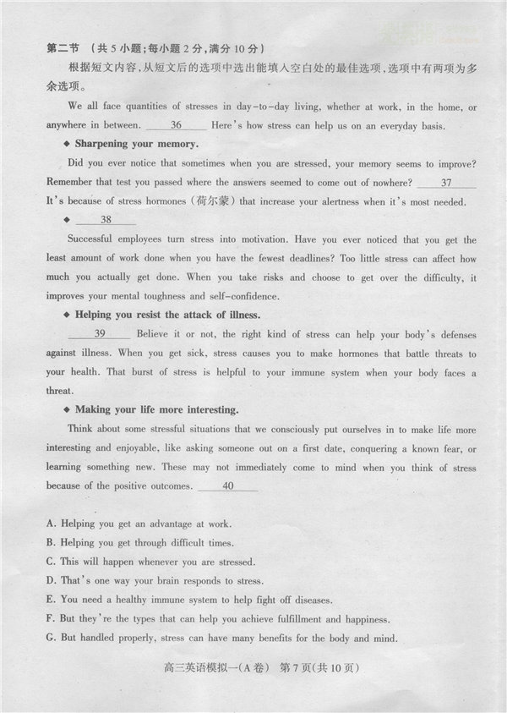

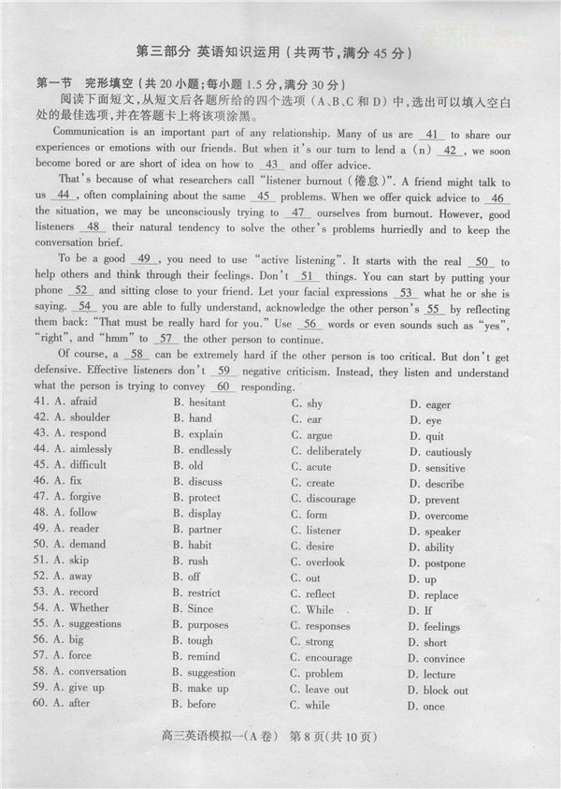

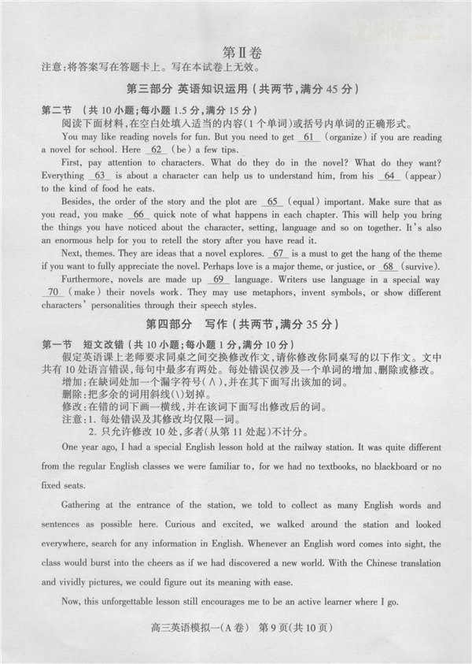

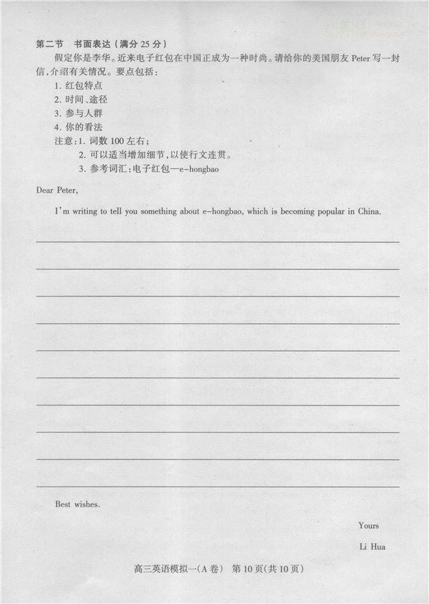

2015届石家庄市高中毕业班第一次模拟考试英语试卷 参考答案
A卷
听力（20×1.5=30）：1—5 BABAC 6—10 BCBCB 11—15 ACCAB 16—20 BACBA
阅读理解（15×2=30）：21—24 CDDA 25—28 BCBA 29—31 CDB 32—35 ACAD
七选五阅读填空（5×2=10）：36—40 GDAEF
完形填空（20×1.5=30）：41—45 DCABB 46—50 ABDCC 51—55 BACAD 56—60 DCADB
B卷
听力（20×1.5=30）：1—5 ABABC 6—10 ACBCB 11—15 BCCAB 16—20 BACAB
阅读理解（15×2=30）：21—24 CDDB 25—28 ACBA 29—31 CDB 32—35 ACBD
七选五阅读填空（5×2=10）：36—40 GDAEF
完形填空（20×1.5=30）：41—45 DCBAB 46—50 ABDCC 51—55 ABCAD 56—60 DCBDA
语法填空（10×1.5=15）：61. organized 62. are 63. that 64. appearance 65. equally
66. a 67. It 68. survival 69. of 70. to make
短文改错（10×1=10）：
One year ago, I had a special English lesson hold at Shijiazhuang Railway Station. It was quite different
held
from the regular English classes we were familiar to, for we had no textbooks, no blackboard or no
with and
fixed seats.
Gathering at the entrance of the station, wetold to collect as many English words and
were
sentences as possible here. Curious and excited, we walked around the station and looked
there
everywhere, search for any information in English. Whenever an English word comes into sight, the
searching came
class would burst into the cheers as if we had discovered a new world. With the Chinese translation
去掉第一个the
and vividly pictures, we could figure out its meaning with ease.
vivid
Now, this unforgettable lesson still encourages me to be an active learner where I go.
wherever
书面表达(满分25分)：
One possible version：
Dear Peter,
I’m writing to tell you something about e-hongbao, which is becoming popular in China.
E-hongbao is actually a kind of lucky money from and to relatives and friends during festivals or on special occasions. For many young people, grabbing e-hongbao on their mobile phones is a fairly common and exciting activity. Unlike the tradition of elders giving lucky money to children, over half of the people sending e-hongbao are in their 20s. It’s just for fun or giving best wishes, while the sum of money matters little. In a word, e-hongbao is bringing new color to the old tradition.
Nevertheless, I’m concerned about the safety of on-line payment. So rules and regulations need to be improved regarding the e-hongbao system to guarantee its operation. (110 words)
Best wishes.
Yours
Li Hua
书面表达评分细则
1、本题总分为25分，按5个档次给分。
2、评分时，先根据文章的内容和语言初步确定其所属档次，然后以该档次的要求来衡量，确定或调整档次，最后给分。
3、词数少于90和多于120的，从总分中减去2分。
4、评分时，应注意的主要内容为：内容要点、应用词汇和语法结构的数量和准确性及上下文的连贯性，根据表达内容的层次适当分段及语言的得体性。
5、拼写与标点符号是语言准确性的一个方面。评分时，应视其对交际的影响程度予以考虑。英、美拼写及词汇用法均可接受。
6、如书写较差，以至影响交际，将分数降低一个档次。
各档次的给分范围和要求
0分：信息未能传达给读者。
第一档：（1—5分）：未完成试题规定的任务。
第二档：（6—10分）：能表达观点，但不够充分，很少句子可读，未恰当完成试题规定的任务。
第三档：（11—15分）：能表达观点，但欠充分，语言错误较多，基本完成了试题规定的任务。
第四档：（16—20分）：观点观确，陈述合理，有部分语言错误，较好地完成了试题规定的任务。
第五档：（21—25分）：观点观确，陈述合理，极少语言错误，很好地完成了试题规定的任务。

