[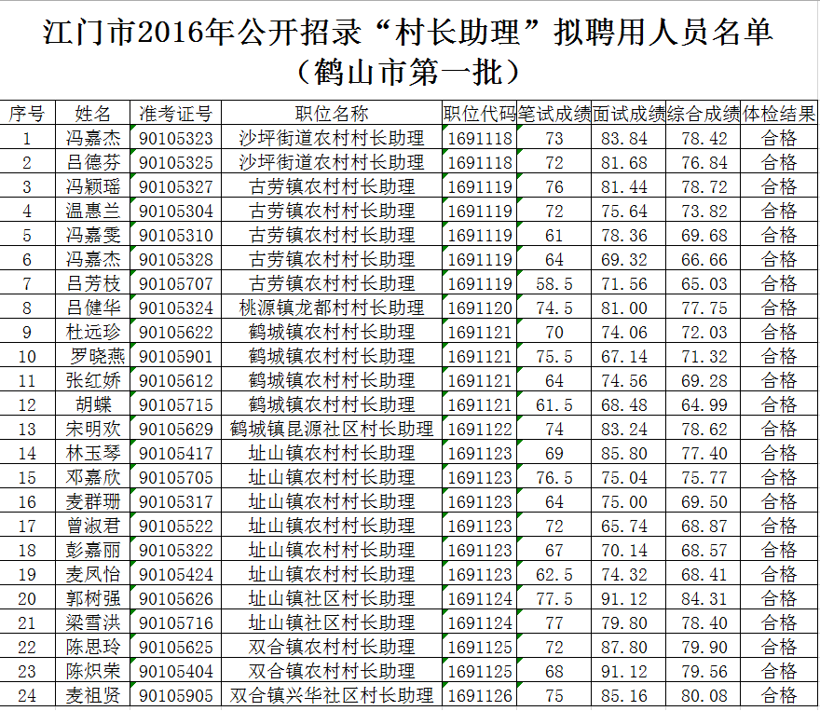](http://zzgz.heshan.gov.cn/zuzhi000/UploadFiles_5502/201610/2016103110511086.png)